
Department of Basic Engineering Science - 1
DATA STRUCTURES THROUGH PYTHON(24SC1204)
I/IV-B.Tech-(II Sem), Academic Year: 2024-2025

Session-3.3 (AVL Tree – Rotation and Operations, AVL Tree Implementation)
Instructional Objective:
- Demonstrate AVL Tree creation
- Describe the AVL Tree and its implementations.
- List out the rotations perform on AVL Tree.
- Describe the balance factor.

Learning Outcomes:
- Define AVL Tree and Balance factor.
- Describe the operation on AVL Tree.
- Summarize the creation, insertion and deletion with examples.

Introduction:
One of the most significant data structures, trees are used to insert, delete, and search for items quickly and effectively. But when dealing with a big amount of data, it is impossible to build a balanced tree to sort everything. As a result, only useful data is kept in a tree, and the amount of data actually used fluctuates as new data is added and older data is removed. It is feasible to conduct traversals, insertions, and deletions without requiring either stack or recursion in some situations when the NULL connection to a binary tree is referred to as a thread. You will discover more about the Height balance tree, which is also known as the AVL tree. The AVL tree named from its designers, Adelson – Velsky and Landis.
Explanation:

Definition: AVL tree is defined as height balanced binary search tree in which each node is associated with a balance factor which is calculated by subtracting the height of its right sub-tree from that of its left sub-tree.
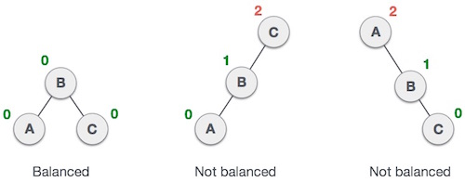

Here we see that the first tree is balanced, and the next two trees are not balanced.
In the second tree, the left subtree of C has height 2 and the right subtree has height 0, so the difference is 2.
In the third tree, the right subtree of A has height 2 and the left is missing, so it is 0, and the difference is 2 again.
Balance Factor = height(left-subtree) − height(right-subtree)
AVL Rotation
AVL Rotation
If the difference in the height of left and right sub-trees is more than 1, the tree is balanced using some rotation techniques.
The first two rotations are single rotations, and the next two rotations are double rotations.

If the difference in the height of left and right sub-trees is more than 1, the tree is balanced using some rotation techniques.
The first two rotations are single rotations, and the next two rotations are double rotations.

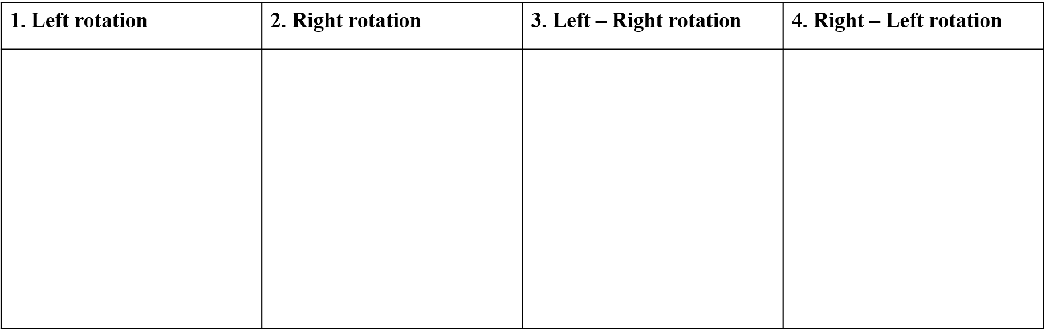
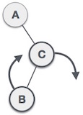
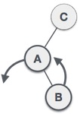
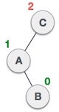
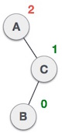
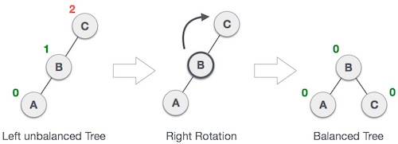
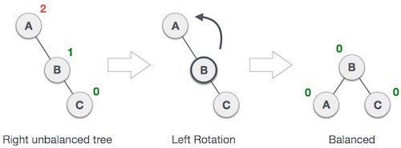

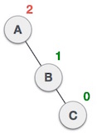
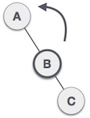
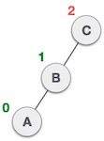
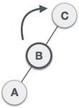

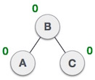

Example: 1

Construct an AVL tree by inserting the following elements in the given order.
63, 9, 19, 27, 18, 10  
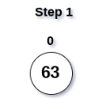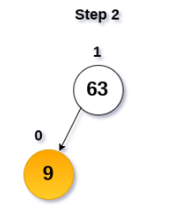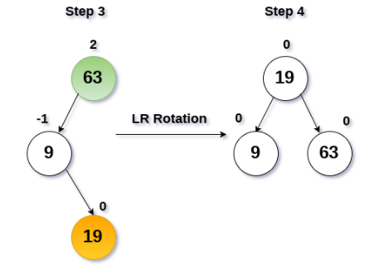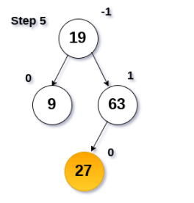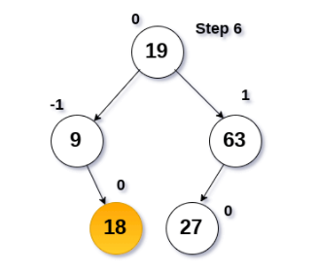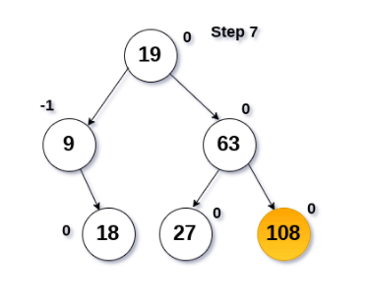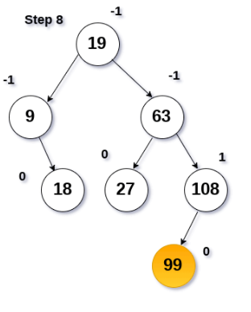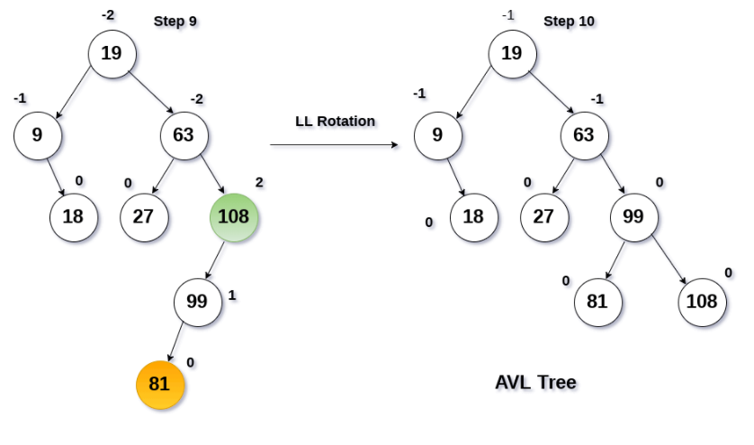
Review questions:
- Describe the AVL Tree and its implementations.
- List out the rotations perform on AVL Tree.
- Describe the balance factor.

Summary:

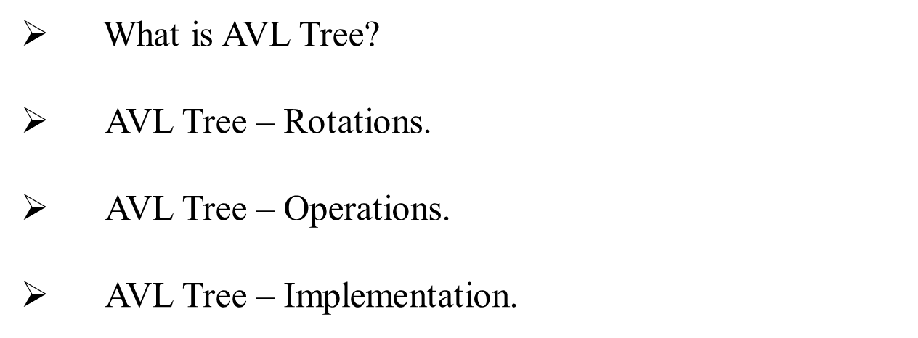

Self-assessment questions:

1. What is an AVL tree?
A.) a tree which is balanced and is a height balanced tree
B.) a tree which is unbalanced and is a height balanced tree
C.) a tree with three children
D.) a tree with atmost 3 children
Ans : A
2. Why we need to a binary tree which is height balanced?
A.) to avoid formation of skew trees
B.) to save memory
C.) to attain faster memory access
D.) to simplify storing
Ans : A
Terminal questions
1. Describe the AVL Tree and Balance Factor?
2. List out the rotations perform on AVL Tree?
3. Analyze the implementation of AVL Tree?
4. Summarize the creation, insertion and deletion operations in AVL Tree?
Practice Problems

- Construct AVL Tree for the following numbers

14, 8, 12, 46, 23, 5, 77, 88, 20

Construct AVL Tree for the following numbers

1, 2, 3, 4, 8, 7, 6, 5, 11, 10, 12

- Construct a binary search tree for data

8, 10, 3, 2, 1, 5, 4, 6

Insert an element 7 into binary search tree using AVL rotation.

